Supplementary File

Hypothetical cohort characteristics
The model considered a hypothetical cohort of patients with baseline characteristics as observed in the REVEAL-AF clinical trial (Table 1). The average CHADS₂ score of the population entering the economic model is 2.94.
Table 1. REVEAL-AF clinical trial cohort characteristics
CHADS₂ score | CHADS₂ 2 | CHADS₂ 3 | CHADS₂ 4 | CHADS₂ 5 | CHADS₂ 6 | All patients
N | 158 | 130 | 75 | 26 | 4 | 393
Mean age | 69.4 | 72.7 | 71.7 | 77.6 | 71.6 | 71.3
% male | 56.33% | 50.77% | 49.33% | 42.31% | 50.00% | 52.03%
Antiplatelet usage at baseline (%)
Yes | 72.15% | 67.69% | 78.67% | 84.62% | 75.00% | 72.59%
History of cerebrovascular accident (stroke) at baseline (%)
Yes | 1.9% | 16.15% | 50.67% | 57.69% | 75.00% | 20.30%
Source for values in table: REVEAL AF, data on file

Subgroup incidence and detection
The AF episode duration threshold at which to initiate OAC therapy was discussed by clinical experts (co-authors KKW, ME, MR); it was agreed that the threshold was dependent on other risk factors included in the CHADS₂ score (e.g. a lower threshold might be used for patients with a history of stroke or high CHADS₂ score, whereas a higher threshold might be appropriate for a patient with a low CHADS₂ score). From the discussion, it was clear that this is an area of high uncertainty and that clinical opinion is likely to vary. Furthermore, 6 minutes was the threshold used in the REVEAL AF study [1], while 5.5 hours has been previously used in the TRENDS data [2].
Given that the model cohort enters the model with an average CHADS₂ score of 2.94, base-case AF episodes were defined as lasting for ≥6 minutes, whilst a scenario analysis explored the impact of AF episodes lasting for ≥5.5 hours.
Table 2. Atrial fibrillation detection (%) observed in REVEAL-AF trial by CHADS₂ subgroup, ≥6 min AF episodes
CHADS₂ score | All patients | CHADS₂ 2 | CHADS₂ 3 | CHADS₂ 4, 5, 6
Timepoints (months)
Month 0 | 0.00% | 0.00% | 0.00% | 0.00%
Month 3 | 13.69% | 12.53% | 16.22% | 12.53%
Month 6 | 20.35% | 18.72% | 22.85% | 19.46%
Month 9 | 23.87% | 20.79% | 26.98% | 24.62%
Month 12 | 27.01% | 23.88% | 29.78% | 29.19%
Month 15 | 27.64% | 23.88% | 30.81% | 29.48%
Month 18 | 29.15% | 24.62% | 32.58% | 31.84%
Month 21 | 31.03% | 25.50% | 35.09% | 34.20%
Month 24 | 33.42% | 28.30% | 39.51% | 34.20%
Month 27 | 38.07% | 34.05% | 44.82% | 36.56%
Month 30 | 39.82% | 34.05% | 49.39% | 36.56%
Source for values in table: REVEAL AF, data on file
Table 3. Atrial fibrillation detection (%) observed in REVEAL-AF trial by CHADS₂ subgroup, ≥5.5 hours AF episodes
CHADS₂ score | All patients | CHADS₂ 2 | CHADS₂ 3 | CHADS₂ 4, 5, 6
Timepoints (months)
Month 0 | 0.26% | 0.64% | 0.00% | 0.00%
Month 3 | 7.20% | 7.71% | 7.77% | 5.79%
Month 6 | 8.81% | 9.05% | 9.41% | 7.77%
Month 9 | 9.90% | 9.72% | 10.28% | 9.80%
Month 12 | 11.03% | 10.42% | 11.15% | 11.89%
Month 15 | 11.91% | 11.13% | 11.15% | 13.98%
Month 18 | 12.84% | 11.13% | 13.15% | 15.10%
Month 21 | 13.55% | 11.13% | 13.15% | 17.66%
Month 24 | 14.96% | 12.19% | 16.00% | 17.66%
Month 27 | 18.76% | 15.71% | 17.72% | 24.34%
Month 30 | 19.52% | 15.71% | 20.07% | 24.34%
Source for values in table: REVEAL AF, data on file
The hazard ratios of the ICM vs. SoC are presented in Table 4, for each of the populations considered in the economic model. Relative diagnostic yield of ICM versus SoC in the base case was sourced from a simulated comparison of AF monitoring strategies using trial data from REVEAL AF [4]. The authors used the ICM data from REVEAL AF to compute the AF incidence and simulate detection by one-time intermittent monitoring strategies over various recording periods following insertion of the ICM. The observed incidence of AF by continuous monitoring with ICM was compared to the simulated incidence of AF by a one-time 24-hour Holter monitor to estimate a hazard ratio of 33.9.
Note that since no information was available from Reiffel et al. [4] for the CHADS₂ subgroups in the REVEAL-AF trial, values observed in the CRYSTAL-AF randomised trial comparing ICM with SoC following cryptogenic stroke were used instead [3]. The hazard ratio estimated from all patients in CRYSTAL-AF was also tested in a scenario analysis.
Table 4. Hazard ratios for ICM vs. SoC for AF detection
CHADS₂ score | Hazard ratio (95% CI) ICM vs. SoC | Notes | Source
All patients (base case) | 33.9 (13.2 – NA) | Estimated from a comparison of observed and simulated AF monitoring strategies using REVEAL AF data | [4]
All patients (scenario analysis) | 8.78 (3.47 to 22.2) | Based on the observed data from CRYSTAL-AF, an RCT in patients with cryptogenic stroke | [3, 5]
CHADS₂ 2 | 39,000,000 (0.00 to -)* |  | [3, 5]
CHADS₂ 3 | 4.89 (1.41 to 16.9) |  | [3, 5]
CHADS₂ 4, 5, 6 | 8.49 (1.97 to 36.5) |  | [3, 5]
*Zero cases of AF were detected with standard of care (SoC)
Abbreviations: AF, atrial fibrillation; CI, confidence interval; ICM, insertable cardiac monitor; NA, not applicable; RCT, randomised controlled trial; SoC, standard of care

Table 5. Calculated per 3-month cycle probabilities of all AF and detected AF by diagnostic strategy, ≥6 min AF episodes
CHADS₂ score | All patients | CHADS₂ 2 | CHADS₂ 3 | CHADS₂ 4, 5, 6
Cycles (3-month intervals)
Cycle 1 | 13.69% | 12.53% | 16.22% | 12.53%
Cycle 2 | 7.71% | 7.08% | 7.92% | 7.92%
Cycle 3 | 4.42% | 2.54% | 5.35% | 6.41%
Cycle 4 | 4.13% | 3.91% | 3.84% | 6.06%
Cycle 5 | 0.86% | 0.00% | 1.47% | 0.42%
Cycle 6 | 2.08% | 0.97% | 2.56% | 3.35%
Cycle 7 | 2.66% | 1.17% | 3.72% | 3.46%
Cycle 8 | 3.46% | 3.76% | 6.81% | 0.00%
Cycle 9 | 6.98% | 8.02% | 8.77% | 3.58%
Cycle 10 | 2.84% | 0.00% | 8.28% | 0.00%
Subsequent cycles | 3.90% | 3.05% | 5.41% | 3.47%

Treatment effects
Event probabilities were calculated by applying treatment effects to an estimate of baseline risk. In some instances, the best estimate of treatment effect was only available by synthesising evidence as described in the following sections.

Ischaemic stroke
The ischaemic stroke (IS) risk in the model is conditional on the treatment administered, virtual CHADS₂ score and AF status. The annual probabilities of IS events as implemented in the economic model were calculated using the network of evidence outlined below (Figure 1).
Figure 1. Network of evidence for risk of ischaemic stroke among patients with AF
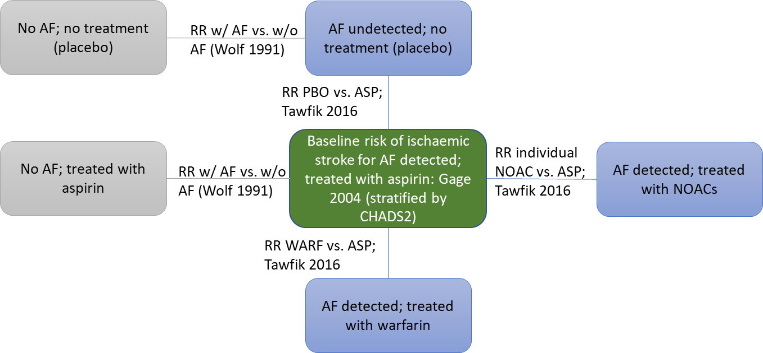
Gage et al. [6] reported the annual risk of ischaemic stroke among patients with diagnosed AF receiving aspirin broken down by CHADS₂ score. These data were used as baseline risk and synthesised with treatment effects to derive the risks associated with other treatments, e.g. non-vitamin K oral anticoagulant (NOAC) and warfarin and to derive the risks associated with being on aspirin treatment but not having AF.
In order to estimate the risk of recurrent IS in AF-free patients taking aspirin or no treatment, the risks reported by Gage et al. [6] were adjusted with a risk ratio (RR = 4.8) from Wolf 1991, to obtain the IS risk of patients without AF [7].
In order to estimate the risk of recurrent IS in AF-free patients taking no treatment, warfarin or NOACs, the risks reported by Gage et al. [6] were synthesised with RR values from a recent systematic review and network meta-analysis of stroke prevention treatments in patients with AF [8].
The annual IS risks by CHADS₂ score are presented in Table 6, while the treatment effects for aspirin, warfarin and NOAC are presented in Table 7.
Table 6. Annual stroke risk
CHADS₂ score | Without AF (AF-free or AF-undetected) |  | With AF
 | No treatment (placebo) | Aspirin | No treatment (placebo) | Aspirin | NOAC | Warfarin
0 | 0.2% | 0.2% | 1.1% | 0.8% | 0.3% | 0.3%
1 | 0.6% | 0.5% | 3.1% | 2.2% | 0.8% | 0.8%
2 | 1.3% | 0.9% | 6.3% | 4.5% | 1.7% | 1.7%
3 | 2.5% | 1.8% | 12.0% | 8.6% | 3.3% | 3.2%
4 | 3.2% | 2.3% | 15.3% | 10.9% | 4.2% | 4.1%
5 | 3.6% | 2.6% | 17.2% | 12.3% | 4.7% | 4.6%
6 | 4.0% | 2.9% | 19.2% | 13.7% | 5.3% | 5.1%
Source | [7] | [7] | [8] | [6] | [8] | [8]
Abbreviations: AF, atrial fibrillation; NOAC, new oral anticoagulant
Table 7. Treatment effects for IS risks
Variable | Mean (95% CI) | Source
RR placebo vs aspirin | 1.40 (1.09 – 1.8) | [8]
RR warfarin vs aspirin | 0.37 (0.29 – 0.48) | Reciprocal of RR value for aspirin vs warfarin [8]
RR NOAC vs aspirin | 0.39 (0.28 – 0.54) | Average of all RR values of individual NOACs (APX, DBG 110, DBG 150, RVX, EDX HD, EDX LD) vs warfarin [8]
Abbreviations: APX, apixaban; CI, confidence interval; DBG, dabigatran; EDX HD, edoxaban high dose; EDX LD, edoxaban low dose; NOAC, new oral anticoagulant; RR, risk ratio; RVX, rivaroxaban

Bleeding events

Baseline risks
Similar to the IS risks, a set of probabilities was selected as baseline risk for one drug and treatment effects were applied to derive the risks for other drugs. For intracranial haemorrhagic (ICH), gastro-intestinal (GI) bleed and clinically relevant non-major (CRNM) bleed, the annual risk for patients on warfarin was estimated by averaging across the warfarin arms of studies that presented data for overall population with AF (ARISTOTLE, RELY, ROCKET and ENGAGE) [9-11]. These values were used as the baseline risk of bleeding events (Table 8).
Table 8. Bleeding event risks with warfarin from each trial and pooled across trials
Outcome | ARISTOTLE | RELY | ROCKET | ENGAGE | Mean warfarin risk | Source
ICH | 0.80% | 0.74% | 0.70% | 0.85% | 0.78% | [12-15]
GI Bleed | 0.79% | 1.02% | 2.16% | 1.23% | 1.28% | [12, 13, 15, 16]
CRNM Bleed | 3.00% | 16.37% | 11.40% | 10.15% | 9.51% | [12, 13, 15, 16]
Abbreviations: CRNM, clinically relevant non-major; GI, gastro-intestinal; ICH, intra-cranial haemorrhage

Treatment effects on bleeding events
The bleeding events risks in the model are conditional on the treatment administered. The annual probabilities of the bleeding events as implemented in the economic model were calculated using the network of evidence outlined below (Figure 2 for ICH, Figure 3 for major bleeds, Figure 4 for CRNM bleeds).
Figure 2. Network of evidence for ICH
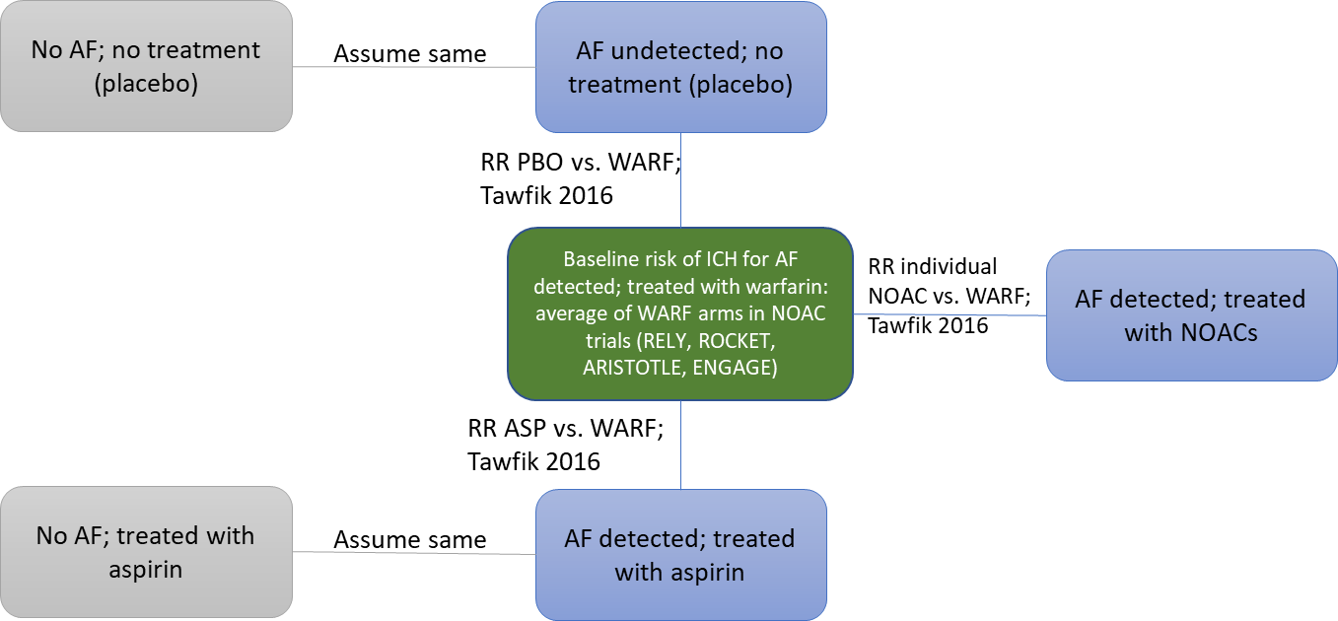

Figure 3. Network of evidence for major bleeds
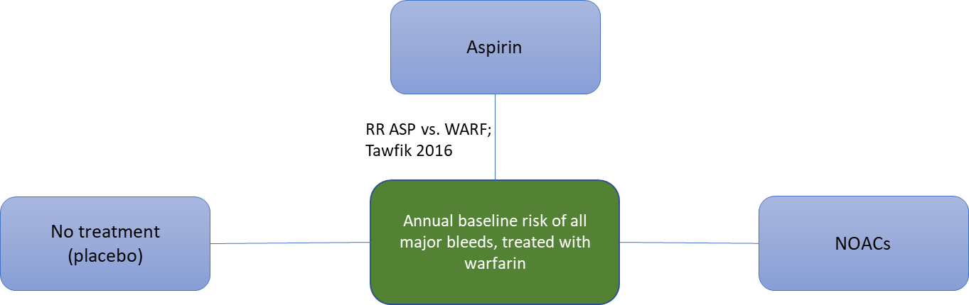

Figure 4. Network of evidence for CRNM bleeds
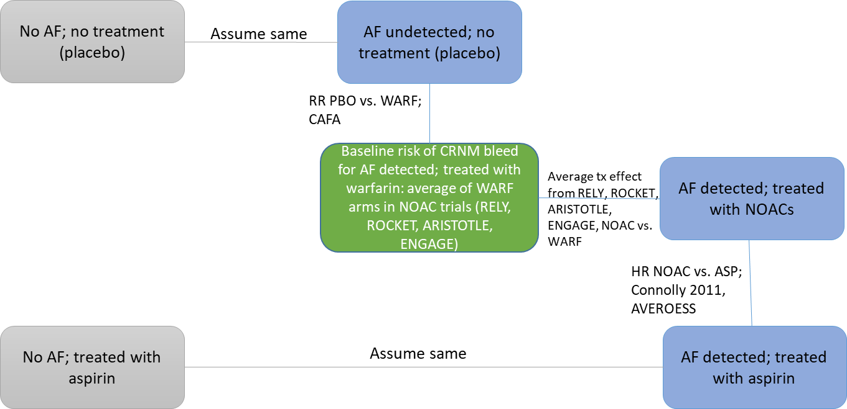
The published and derived treatment effects for all bleeding events are summarised in Table 9 and the resulting annual risk of such events are presented in Table 10.
Table 9. Treatment effects for bleeding events
Variable | Mean (95% CI) | Source
ICH
RR placebo vs warfarin | 0.22 (0.07 – 0.65) | [8]
RR aspirin vs warfarin | 0.64 (0.39 – 1.04) | [8]
RR NOAC vs warfarin | 0.42 (0.19 – 0.91) | Average of all RR values of individual NOACs (APX, DBG 110, DBG 150, RVX, EDX HD, EDX LD) vs warfarin [8]
Major bleed
RR placebo vs warfarin | 0.57 (0.32 – 1) | [8]
RR aspirin vs warfarin | 0.77 (0.61 – 0.98) | [8]
RR NOAC vs warfarin | 0.80 (0.41 – 1.19) | Average of all RR values of individual NOACs (APX, DBG 110, DBG 150, RVX, EDX HD, EDX LD) vs warfarin [8]
CRNM bleed
RR placebo vs warfarin | 0.55 (0.32 – 0.97) | Reciprocal value of RR warfarin vs placebo [17]
HR NOAC vs warfarin | 0.83 (0.66 – 1.04) | Average of all HR values of individual NOACs (APX, DBG 110, DBG 150, RVX, EDX HD, EDX LD) vs warfarin [12, 13, 15, 16]
HR NOAC vs aspirin | 1.15 (0.86 – 1.54) | [18]
Abbreviations: APX, apixaban; CI, confidence interval; CRNM, clinically relevant non-major; DBG, dabigatran; EDX HD, edoxaban high dose; EDX LD, edoxaban low dose; ICH, intra-cranial haemorrhage; HR, hazard ratio; NOAC, new oral anticoagulant; RR: risk ratio / relative risk; RVX, rivaroxaban

Event severity

Ischaemic stroke severity
The proportion of ischaemic stroke events that are categorised as mild, moderate, severe or fatal was sourced from two published cost-effectiveness analyses [16, 19]. The authors provided a distribution of severity for each drug separately; however, for the model presented here we assumed the severity distribution was not treatment-dependent. The average across all drugs, as well as the drug-specific distributions, are presented in Table 10.
Table 10. Ischaemic stroke severity distribution
Ischaemic stroke severity | APX | DBG (110) | DBG (150) | RVX | Aspirin | Warfarin | Overall
% mild (mRS 0-2) | 53 | 35 | 35 | 49 | 36 | 45 | 42.2
% moderate (mRS 3-4) | 21 | 28 | 22 | 18 | 38 | 30 | 26.2
% severe (mRS 5) | 8 | 10 | 8 | 6 | 15 | 10 | 9.5
% fatal (mRS 6) | 18 | 27 | 35 | 27 | 11 | 15 | 22.2
Abbreviations: APX, apixaban; DBG, dabigatran; EDX HD, edoxaban high dose; mRS, modified Rankin Scale; RVX, rivaroxaban

Intracranial haemorrhage and extracranial haemorrhage
The proportion of ICH that are haemorrhagic strokes (HS) and the severity of those haemorrhagic strokes were reported for each drug in two published cost-effectiveness analyses [16, 19]. For simplicity, we assumed the likelihood that an ICH was a haemorrhagic stroke was independent of treatment and thus took an average across all drugs (see Table 11). Similarly, the severity distribution was also assumed to be independent of treatment.
Extracranial haemorrhages are broken down into two events: GI bleeds and non-GI/non-ICH related bleeds (e.g. "other ECH"). Similarly to the ICH haemorrhages, we assumed the probability that an extracranial haemorrhage (ECH) was a GI bleeding event was independent of treatment and used an average from previously reported risks ( Table 11) [16, 19].
Table 11. ICH- and ECH-related probabilities
 | APX | DBG (110) | DBG (150) | RVX | Aspirin | Warfarin | Overall
ICH
%ICH are HS | 77 | 64 | 41 | 57 | 55 | 64 | 59.7
% HS mild | 23 | 35 | 35 | 49 | 7 | 20 | 28.2
% HS moderate | 32 | 28 | 22 | 18 | 20 | 15 | 22.5
% HS severe | 10 | 10 | 8 | 6 | 27 | 12 | 12.2
% HS fatal | 35 | 27 | 35 | 27 | 46 | 53 | 37.2
% ICH are other ICH | 23 | 36 | 59 | 43 | 45 | 36 | 40.3
% other ICH fatal |  |  |  |  |  |  | 13.0
ECH
% ECH are GI bleed | 38 | 41 | 49 | 45 | 39 | 39 | 41.8
% ECH fatal |  |  |  |  |  |  | 2.0
Permanent OAC discontinuation following major bleeding event
% discontinue following HS |  |  |  |  |  |  | 100
% discontinue following "other ICH" |  |  |  |  |  |  | 56
% discontinue following ECH |  |  |  |  |  |  | 25
Abbreviations: APX, apixaban; DBG, dabigatran; ECH, extra-cranial haemorrhage; EDX HD, edoxaban high dose; HS, haemorrhagic stroke; ICH, intra-cranial haemorrhage; OAC, oral anticoagulant; RVX, rivaroxaban

Mortality

Non-cerebrovascular mortality
Age-dependant mortality was based on rates from interim life tables for the UK [20]. Deaths from cerebrovascular events are explicitly modelled. To avoid double counting, the life-table risks were reduced by the proportion of cerebrovascular cases to the total all-cause cases (Table 12), to reflect a baseline mortality risk due any cause other than a cerebrovascular episode [21]. Since the baseline mortality risk and the adjustment factors are based on national data, the level of uncertainty in the model input was considered to be very low and did not warrant incorporation to the probabilistic sensitivity analysis (PSA).
Table 12. Non-cerebrovascular mortality as a percentage of all mortality
Deaths by age | Sex | 50-54 | 55-59 | 60-64 | 65-69 | 70-74 | 75-79 | 80-84 | 85-89 | 90-94 | 95 +
All cause | M | 7,076 | 9,689 | 14,289 | 21,901 | 26,311 | 34,589 | 41,831 | 40,126 | 25,635 | 7,008
 | F | 4,856 | 6,501 | 9,677 | 14,938 | 19,268 | 27,917 | 41,029 | 50,909 | 47,921 | 22,856
Cerebrovascular diseases | M | 267 | 373 | 478 | 845 | 1,243 | 2,071 | 2,901 | 2,986 | 2,080 | 537
 | F | 212 | 256 | 363 | 675 | 1,047 | 1,950 | 3,494 | 4,879 | 4,667 | 2,106
Cerebrovascular death as % of all deaths | M | 3.8% | 3.8% | 3.3% | 3.9% | 4.7% | 6.0% | 6.9% | 7.4% | 8.1% | 7.7%
 | F | 4.4% | 3.9% | 3.8% | 4.5% | 5.4% | 7.0% | 8.5% | 9.6% | 9.7% | 9.2%
Abbreviations: F, female; M, male
Moreover, we considered that the model population includes patients with recent history of a non-fatal stroke or TIA, which, evidence shows, increases their risk of all-cause mortality [22]. Using data from Brønnum-Hansen et al. [22] and Huybrechts et al. [23] we estimated the hazard ratio of a non-fatal mild stroke on non-cerebrovascular death to be 1.97 compared to the general population.

Mortality post recurrent stroke event
An excess mortality risk was applied to patients in post-stroke event health states; that is, after a recurrent stroke (Table 13). Brønnum-Hansen et al. [22] reported a 2.71 mortality HR for patients after a non-fatal stroke versus the general population. We synthesised this with data from another study to adjust the HR for the severity of the stroke event.
Huybrechts et al. [23] presented mortality HRs of patients experiencing events of different severity, expressed in modified Rankin Scale (mRS). Assuming that the HR from Brønnum-Hansen et al. [22] relates to a mRS score of 2 in the Huybrechts et al. [23] data, we compared the HR of mRS 1 to 2 (average of 0 vs 1 and 1 vs 2) versus the mRS of 2 to derive a HR for mild stroke. A similar calculation was repeated for moderate stroke (3 to 4 vs 2), and severe stroke (5 vs 2).
Table 13. Estimation of excess all-cause mortality attributed to mild, moderate and severe stroke events
Risk factor | Hazard ratio | Notes / Source
Post non-fatal stroke (assumed mild) vs general population | 2.71 | [22]
mRS 1 vs 0 | 1.18 | [23]
mRS 2 vs 1 | 1.32 | [23]
mRS 3 vs 2 | 1.16 | [23]
mRS 4 vs 3 | 1.43 | [23]
mRS 5 vs 4 | 2.23 | [23]
Re-categorised mRS factors from Huybrechts et al. [23]
mRS 1 to 2 vs 2 | 0.95 | =([1.18+1.32]/2)/1.32
mRS 3 to 4 vs 2 | 1.71 | =1.32* ([1.16+1.43]/2)
mRS 5 vs 2 | 4.87 | =2.23*1.43*1.16*1.32
Adjusted values for model
Mild stroke | 2.56 | =0.95*2.71
Moderate stroke | 4.63 | =1.71*2.71
Severe stroke | 13.18 | =4.87*2.71

Treatment effects on all-cause mortality
Patients in the post-stroke health states continue to receive treatment with either placebo (no treatment), aspirin or OAC therapy. Randomised controlled trial evidence has shown these treatments to have an impact on all-cause mortality [9-11, 24-26].
The network of evidence available for all-cause mortality is presented in Figure 5, while treatment effects are listed in Table 14.
Figure 5. Network of evidence for all-cause mortality
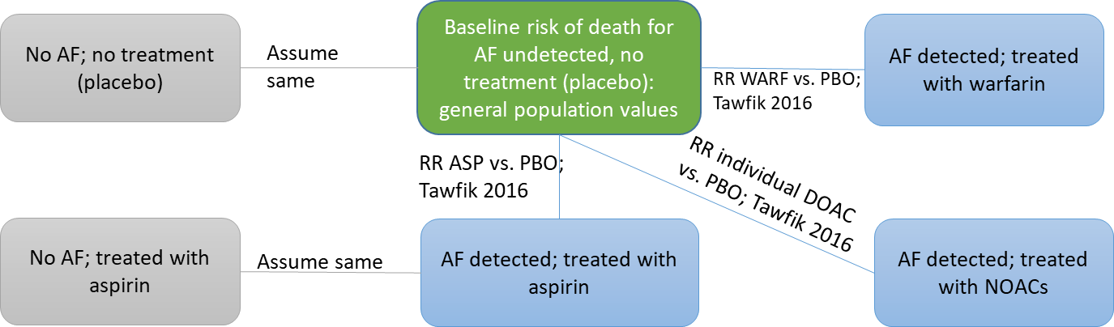
Table 14. Treatment effects for all-cause mortality
Variable | Mean (95% CI) | Source
RR aspirin vs placebo | 0.86 (0.69 – 1.06) | Reciprocal value of RR for placebo vs aspirin [8]
RR warfarin vs aspirin | 0.82 (0.64 – 1.06) | [8]
RR NOAC vs aspirin | 0.74 (0.56 – 0.98) | Average of all RR values of individual NOACs (APX, DBG 110, DBG 150, RVX, EDX HD, EDX LD) vs. PBO [8]
Abbreviations: APX, apixaban; DBG, dabigatran; EDX HD, edoxaban high dose; EDX LD, edoxaban low dose; RR, risk ratio; RVX, rivaroxaban

Health-related quality of life

Utility values from the literature
The analysis used evidence from an OXVASC study publication for stroke-related health related quality of life (HRQoL) values [22] and two cost-effectiveness analyses of apixaban [9, 10] for bleeding event values. The OXVASC study provided estimates of HRQoL over 5 years follow-up from an index stroke event using EQ-5D and UK population valuations. The study presented utility data at different time intervals (1, 6, 12, 24 and 60 months) following the index event. Values measured at 1 month were used as the acute event utility weight for mild, moderate and severe ischaemic and hemorrhagic stroke and other ICH. A weighted average (with weights based on time) of the 6, 12, 24 and 60-month values was used as the utility weight for the post-stroke health states.
The authors also performed a regression to identify predictors of EQ-5D utility at 1 month and 5 years after the index TIA or stroke. They found that a history of atrial fibrillation was associated with a statistically significant utility decrement of 0.052 at 1 month and a non-significant utility gain of 0.024 at 5 years. An average of these values was used in the model to adjust for the presence of AF at the point it is developed.
Similarly, the OXVASC study authors found that a recurrent stroke during follow-up was associated with a significant decrement of 0.150 at 1 month and 0.068 at 5 years. All strokes that occurred during the model were recurrent strokes, and therefore, carried the above penalties.
Evidence regarding the utility associated with ECH and CRNM bleeds was extremely limited. In the absence of better evidence, values were taken directly from two cost-effectiveness analyses of apixaban [9, 10]. The authors of these studies used a UK-based utility catalogue [23] to obtain utility decrements associated with ECH and CRNM bleeds.
The disutility associated with acute events was confined to a certain duration. For strokes (ischaemic or hemorrhagic) and other ICH, the acute disutility was assumed to last for the duration of one cycle (i.e. 3 months). For ECH, the acute disutility was assumed to last for 2 weeks and for CRNM bleeds, for just 2 days. The assumptions around the duration of these utility decrements were taken from [9, 10]. They arrived at these values through clinical expert opinion.
Table 15 presents the utility scores used in the economic model for each health state and event.
Table 15. Health state utilities
Health state / event | Mean utility in study | Source
REVEAL AF baseline | 0.773 | REVEAL AF data on file
History of AF | 0.719 | OXVASC [22]
Mild stroke event (IS or HS) | 0.730 | OXVASC [22]
Moderate stroke event (IS or HS) | 0.500 | OXVASC [22]
Severe stroke event (IS or HS) | 0.130 | OXVASC [22]
Recurrent stroke event | 0.589 | OXVASC [22]
Post mild stroke (IS or HS) | 0.727 | OXVASC [22]
Post moderate stroke (IS or HS) | 0.582 | OXVASC [22]
Post severe stroke (IS or HS) | 0.397 | OXVASC [22]
Post recurrent stroke | 0.659 | OXVASC [22]
Other ICH event | 0.700 | OXVASC [22]
CRNM bleed | 0.9997ª | [9, 10, 23]
ECH | 0.9942^{b} | [9, 10, 16, 19, 23, 27]
Notes: ª disutility from CRNM bleed assumed to last 2 days; ^{b} disutility from ECH assumed to last 2 weeks
Abbreviations: AF, atrial fibrillation; CRNM, clinically relevant non-major; ECH, extra-cranial haemorrhage; HS, haemorrhagic stroke; ICH, intra-cranial haemorrhage; IS, ischaemic stroke

Synthesis of utility values
The health state utilities in Table 15 were synthesized with a baseline utility; the latter assumed to reflect the natural decline of patients’ physical and mental functions due to age and other co-morbidities. The baseline utility value was taken from a model by Ara and Brazier [28].
Since some patients entered the model with a history of stroke (20.3%, see Table 1), the characteristics of this mixed cohort was built in the utility multipliers as weighted averages accounting for utilities after an initial stroke and recurrent stroke.
Table 16. Health state and acute event utility multipliers
Health state | φ
No AF | 1.000
AF | 0.9809
Post-mild stroke - No AF | 0.9451
Post-mild stroke - AF | 0.9270
Post-moderate stroke - No AF | 0.7566
Post-moderate stroke - AF | 0.7422
Post-severe stroke - No AF | 0.5161
Post-severe stroke - AF | 0.5063
Dead
Acute event
Mild recurrent stroke | 0.9269
Moderate recurrent stroke | 0.6349
Severe recurrent stroke | 0.1651
Other ICH | 0.9270
ECH | 0.9942
CRNM bleed | 0.9997
Abbreviations: AF, atrial fibrillation; CRNM, clinically relevant non-major; ECH, extra-cranial haemorrhage; ICH, intra-cranial haemorrhage

Resource use and costs

Conventional follow-up (SoC) resource use
As part of a clinical advisory board, clinical experts (co-authors KW, ME, MR) were asked to describe the conventional follow-up or SoC for patients deemed at high risk of AF. There was consensus to assume one 24-hr Holter monitoring each year with a relative accuracy of Reveal vs. SoC of 33.9 [4]. The unit cost for a Holter monitoring tests is assumed to be the same based on an HRG of “Electrocardiogram monitoring and stress testing”. The unit cost of the Holter monitor was assumed to be £151.5, which corresponded to 2012-2013 NHS Reference costs unit cost, inflated to 2015-2016 values [29, 30].

Drug and INR monitoring costs
Patients treated with warfarin accrued costs associated with international normalized ratio (INR) monitoring. The annual cost of INR monitoring was taken from Dorian et al. [16] who estimated the cost assuming that patients would have 18 monitoring visits per year, a frequency consistent with activity levels reported by the NHS. The cost was inflated to 2015-2016 values using the Hospital and Community Health Services (HCHS) inflation indices [29]. The annual monitoring cost per patient used in the model was estimated at £266.40.
The cost per cycle for each drug and INR monitoring is displayed in Table 17.
Table 17. Drug and monitoring costs
Drug | Cost per cycle | Source
Aspirin | £6.02 | MIMS (July 2018) [31]
Warfarin | £5.71
Warfarin INR monitoring | £66.60 | [16, 19]
NOAC | £159.43 | Per-cycle average cost of daily [31]  - 10 mg apixaban: £172.90  - 20 mg rivaroxaban: £155.61  - 300 mg dabigatran: £154.70  - 220 mg dabigatran: £154.70  - 60 mg edoxaban: £159.25
Abbreviations: INR, International Normalised Ratio; MIMS, Monthly Index of Medical Specialities; NOAC, new oral anticoagulant

Acute care costs associated with clinical events
Stroke costs were categorised according to type (i.e. haemorrhagic or non-haemorrhagic), severity (mild, moderate, severe or fatal) and time (acute or post-acute maintenance). Costs for each permutation of these categories were available from Luengo-Fernandez et al. [32] and were inflated to 2015/16 costs using the HCHS inflation indices [29].
Costs of major bleeds (other ICH, GI bleed, other ECH) and CRNM bleeds were calculated as weighted averages of several HRG codes and settings from the most recent NHS Reference Costs database [33]. The description of how costs were estimated along with the final unit costs is presented in Table 18.
Uncertainty around the NHS reference costs was estimated by assuming that the interquartile range for any given NHS reference cost fit a lognormal distribution. Based on that assumption, we took the mean and manually adjusted the standard error estimate to calculate parameters for a lognormal distribution that would come closest to reproducing the interquartile range reported in the NHS reference costs schedule.
For the probabilistic sensitivity analysis, we wanted an estimate of uncertainty around the weighted average cost of each bleeding event from the NHS reference costs. To estimate this uncertainty, we performed a separate Monte Carlo (i.e. outside of the economic model) in which each cost component was sampled independently, multiplied by its relative weight and then summed. The result was a weighted average and standard error based on 10,000 samples which could be used as a single input to the economic model for each type of bleeding event.

Table 18. Major bleeds and CRNM bleeds unit cost assumptions
Acute event | Unit cost | 95% CI | HRG codes used | Settings considered
HS | £2,880.41 | £2,085.32 - £3,810.69 | AA23, haemorrhagic cerebrovascular disorders | NEL, NEL_XS, NES
GI bleeds | £856.37 | £724.51 - £998.81 | FD03, gastrointestinal bleed | NEL, NEL_XS, NES
Non-ICH and non-GI major bleeds | £2,118.36 | £1,895.37 - £2,355.54 | HC28, spinal cord conditions without interventions; HD24, other acquired cardiac conditions; BZ24, non-surgical ophthalmology without intervention; EB14, other acquired cardiac condition; FF51, major general abdominal procedures | NEL, NEL_XS, NES
CRNM bleeds | £472.66 | £347.47 - £623.33 | FD03, gastrointestinal bleed; CA23, intermediate nose procedures; LB38, unspecified haematuria | NES
Abbreviations: CI, confidence interval; CRNM, clinically relevant non-major; GI, gastro-intestinal; HRG, Healthcare Resource Group; HS, haemorrhagic stroke; ICH, intra-cranial haemorrhage; NEL, non-elective long stay; NEL_XS, non-elective long stay, excess days; NES, non-elective short stay

Results
Table 19. Two-way sensitivity analysis results for SoC monitoring assumptions
% reduction in cost of SoC/HR Reveal ICM vs. SoC | 80%: HR=27.10 | 60%: HR=20.33 | 40%: HR=13.55 | 20%: HR=6.78 | 10%: HR=3.39 | 5%: HR=1.69 | 0%*: HR=0.34
80%: SoC cost=£121.20 | £8,022 | £8,252 | £8,735 | £10,375 | £14,813 | £33,994 | Reveal® dominated
60%: SoC cost=£90.90 | £8,772 | £9,009 | £9,505 | £11,192 | £15,753 | £35,467 | Reveal® dominated
40%: SoC cost=£60.60 | £9,523 | £9,767 | £10,276 | £12,008 | £16,694 | £36,940 | Reveal® dominated
20%: SoC cost=£30.30 | £10,274 | £10,524 | £11,047 | £12,825 | £17,634 | £38,413 | Reveal® dominated
10%: SoC cost=£15.15 | £10,649 | £10,902 | £11,432 | £13,233 | £18,104 | £39,149 | Reveal® dominated
5%: SoC cost=£7.58 | £10,837 | £11,092 | £11,625 | £13,438 | £18,339 | £39,517 | Reveal® dominated
0%: SoC cost=£0.00 | £11,025 | £11,281 | £11,818 | £13,642 | £18,574 | £39,885 | Reveal® dominated
Notes: *To explore a scenario where the ICM and SoC are equivalent, the base-case HR (33.88) was multiplied by 0.01, as multiplication by 0 would create technical (Excel) errors.
Abbreviations: HR, hazard ratio; ICM, insertable cardiac monitor; SoC, standard of care

Figure 6. Cost–effectiveness Acceptability Curve for ICM vs. SoC
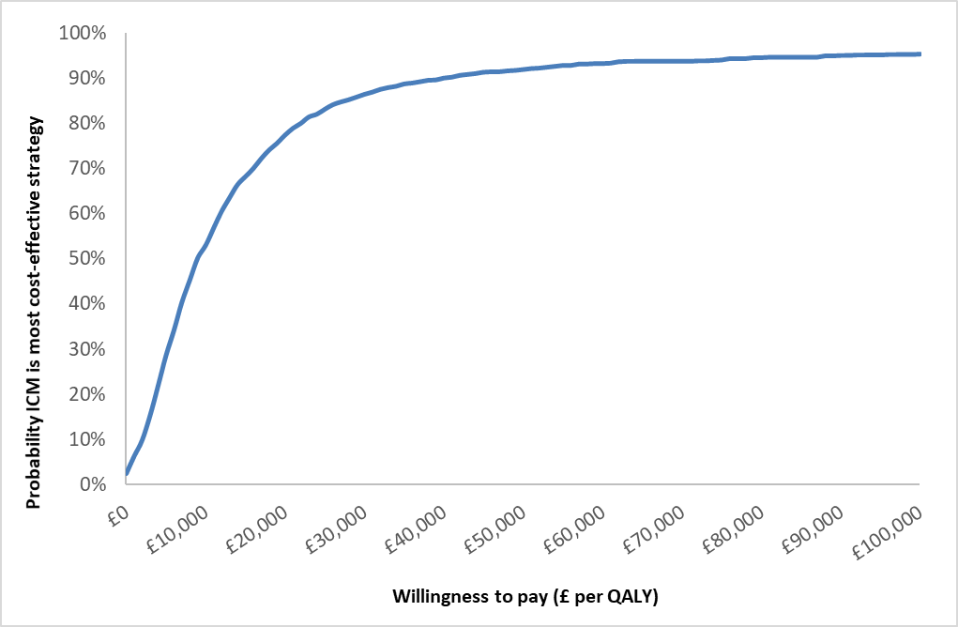
Abbreviations: ICM, insertable cardiac monitor; QALY, quality-adjusted life-year; SoC, standard of care

Supplementary File References
1. Reiffel JA, Verma A, Kowey PR, Halperin JL, Gersh BJ, Wachter R, et al. Incidence of Previously Undiagnosed Atrial Fibrillation Using Insertable Cardiac Monitors in a High-Risk Population: The REVEAL AF Study. JAMA cardiology. 2017;2(10):1120-7.
2. Glotzer TV, Daoud EG, Wyse DG, Singer DE, Ezekowitz MD, Hilker C, et al. The relationship between daily atrial tachyarrhythmia burden from implantable device diagnostics and stroke risk: the TRENDS study. Circulation Arrhythmia and electrophysiology. 2009;2(5):474-80.
3. Sanna T, Diener HC, Passman RS, Di Lazzaro V, Bernstein RA, Morillo CA, et al. Cryptogenic stroke and underlying atrial fibrillation. The New England journal of medicine. 2014;370(26):2478-86.
4. Reiffel JA, Kowey P, Halperin J, Gersh B, Elkind MSV, et al. A Comparison of Atrial Fibrillation Monitoring Strategies in Patients at High Risk for Atrial Fibrillation and Stroke: Results from the REVEAL AF Study. Journal of the American College of Cardiology. 2018;71(11 Supplement):A274.
5. Diamantopoulos A, Sawyer LM, Lip GY, Witte KK, Reynolds MR, Fauchier L, et al. Cost-effectiveness of an insertable cardiac monitor to detect atrial fibrillation in patients with cryptogenic stroke. International journal of stroke : official journal of the International Stroke Society. 2016;11(3):302-12.
6. Gage BF, van Walraven C, Pearce L, Hart RG, Koudstaal PJ, Boode BS, et al. Selecting patients with atrial fibrillation for anticoagulation: stroke risk stratification in patients taking aspirin. Circulation. 2004;110(16):2287-92.
7. Wolf PA, Abbott RD, Kannel WB. Atrial fibrillation as an independent risk factor for stroke: the Framingham Study. Stroke; a journal of cerebral circulation. 1991;22(8):983-8.
8. Tawfik A, Bielecki JM, Krahn M, Dorian P, Hoch JS, Boon H, et al. Systematic review and network meta-analysis of stroke prevention treatments in patients with atrial fibrillation. Clinical pharmacology : advances and applications. 2016;8:93-107.
9. Easton JD, Lopes RD, Bahit MC, Wojdyla DM, Granger CB, Wallentin L, et al. Apixaban compared with warfarin in patients with atrial fibrillation and previous stroke or transient ischaemic attack: a subgroup analysis of the ARISTOTLE trial. The Lancet Neurology. 2012;11(6):503-11.
10. Diener HC, Eikelboom J, Connolly SJ, Joyner CD, Hart RG, Lip GY, et al. Apixaban versus aspirin in patients with atrial fibrillation and previous stroke or transient ischaemic attack: a predefined subgroup analysis from AVERROES, a randomised trial. The Lancet Neurology. 2012;11(3):225-31.
11. Hankey GJ, Patel MR, Stevens SR, Becker RC, Breithardt G, Carolei A, et al. Rivaroxaban compared with warfarin in patients with atrial fibrillation and previous stroke or transient ischaemic attack: a subgroup analysis of ROCKET AF. The Lancet Neurology. 2012;11(4):315-22.
12. Connolly SJ, Ezekowitz MD, Yusuf S, Eikelboom J, Oldgren J, Parekh A, et al. Dabigatran versus warfarin in patients with atrial fibrillation. The New England journal of medicine. 2009;361(12):1139-51.
13. Giugliano RP, Ruff CT, Braunwald E, Murphy SA, Wiviott SD, Halperin JL, et al. Edoxaban versus warfarin in patients with atrial fibrillation. The New England journal of medicine. 2013;369(22):2093-104.
14. Granger CB, Alexander JH, McMurray JJ, Lopes RD, Hylek EM, Hanna M, et al. Apixaban versus warfarin in patients with atrial fibrillation. The New England journal of medicine. 2011;365(11):981-92.
15. Patel MR, Mahaffey KW, Garg J, Pan G, Singer DE, Hacke W, et al. Rivaroxaban versus warfarin in nonvalvular atrial fibrillation. The New England journal of medicine. 2011;365(10):883-91.
16. Dorian P, Kongnakorn T, Phatak H, Rublee DA, Kuznik A, Lanitis T, et al. Cost-effectiveness of apixaban vs. current standard of care for stroke prevention in patients with atrial fibrillation. European heart journal. 2014;35(28):1897-906.
17. Connolly SJ, Laupacis A, Gent M, Roberts RS, Cairns JA, Joyner C. Canadian Atrial Fibrillation Anticoagulation (CAFA) Study. Journal of the American College of Cardiology. 1991;18(2):349-55.
18. Connolly SJ, Eikelboom J, Joyner C, Diener HC, Hart R, Golitsyn S, et al. Apixaban in patients with atrial fibrillation. The New England journal of medicine. 2011;364(9):806-17.
19. Lip GY, Kongnakorn T, Phatak H, Kuznik A, Lanitis T, Liu LZ, et al. Cost-effectiveness of apixaban versus other new oral anticoagulants for stroke prevention in atrial fibrillation. Clinical therapeutics. 2014;36(2):192-210 e20.
20. Office for National Statistics. National life tables, United Kingdom, based on data for the years 2014-20162017. Available from: http://www.ons.gov.uk/ons/rel/lifetables/national-life-tables/2010---2012/stb-uk-2010-2012.html.
21. Office for National Statistics. Mortality statistics: Deaths: underlying cause, sex and age-group, 2014: Chapter IX. Diseases of the circulatory system. England and Wales.2014. Available from: http://www.ons.gov.uk/ons/rel/vsob1/mortality-statistics--deaths-registered-in-england-and-wales--series-dr-/2012/index.html.
22. Bronnum-Hansen H, Davidsen M, Thorvaldsen P, Danish MSG. Long-term survival and causes of death after stroke. Stroke; a journal of cerebral circulation. 2001;32(9):2131-6.
23. Huybrechts KF, Caro JJ, Xenakis JJ, Vemmos KN. The prognostic value of the modified Rankin Scale score for long-term survival after first-ever stroke. Results from the Athens Stroke Registry. Cerebrovascular diseases. 2008;26(4):381-7.
24. Diener HC, Connolly SJ, Ezekowitz MD, Wallentin L, Reilly PA, Yang S, et al. Dabigatran compared with warfarin in patients with atrial fibrillation and previous transient ischaemic attack or stroke: a subgroup analysis of the RE-LY trial. The Lancet Neurology. 2010;9(12):1157-63.
25. Ntaios G, Papavasileiou V, Diener HC, Makaritsis K, Michel P. Nonvitamin-K-antagonist oral anticoagulants in patients with atrial fibrillation and previous stroke or transient ischemic attack: a systematic review and meta-analysis of randomized controlled trials. Stroke; a journal of cerebral circulation. 2012;43(12):3298-304.
26. Secondary prevention in non-rheumatic atrial fibrillation after transient ischaemic attack or minor stroke. EAFT (European Atrial Fibrillation Trial) Study Group. Lancet. 1993;342(8882):1255-62.
27. Sullivan PW, Slejko JF, Sculpher MJ, Ghushchyan V. Catalogue of EQ-5D scores for the United Kingdom. Medical decision making: an international journal of the Society for Medical Decision Making. 2011;31(6):800-4.
28. Ara R, Brazier JE. Populating an economic model with health state utility values: moving toward better practice. Value in health: the journal of the International Society for Pharmacoeconomics and Outcomes Research. 2010;13(5):509-18.
29. Curtis L. Unit costs of health and social care. Canterbury: Personal Social Services Research Unit, University of Kent; 2018.
30. Department of Health. NHS reference costs 2012-2013. 2013. Available from: https://www.gov.uk/government/publications/nhs-reference-costs-2012-to-2013.
31. Monthly Index of Medical Specialities (MIMS). Online version 2018. Available from: http://www.mims.co.uk/.
32. Luengo-Fernandez R, Paul NL, Gray AM, Pendlebury ST, Bull LM, Welch SJ, et al. Population-based study of disability and institutionalization after transient ischemic attack and stroke: 10-year results of the Oxford Vascular Study. Stroke; a journal of cerebral circulation. 2013;44(10):2854-61.
33. Department of Health. NHS reference costs 2016-2017. 2017. Available from: https://improvement.nhs.uk/resources/reference-costs/.

