**Supplementary Materials**

**Fractional flow reserve in acute coronary syndrome: A meta-analysis and systematic review**

Contents

Search Strategy 3

Search Hedges 3

Figures 4

Figure S1A. Assessment of Study Bias 4

Figure S1B. Funnel Plot for Assessment of Publication Bias 5

Figure S2. FFR vs. Angiography alone in the management of patients with ACS. A) MACE; B) All-cause mortality; C) Recurrent myocardial infarction; D) Unplanned revascularisation 6

Figure S3. FFR guided deferral of PCI in patients with ACS and stable CAD: unplanned target vessel/lesion revascularization 7

Figure S4. Leave-one-out analysis evaluating the impact of individual study omission from the analysis on the overall effect estimate (incidence of MACE) 8

Tables 9

Table S1. Selection Criteria and pre-specified endpoints of included studies 9

Table S2. Baseline Lesion Characteristics 13

# Search Strategy

## Search Hedges

(FFR OR Fractional Flow Reserve) AND (acute coronary syndrome OR ACS OR myocardial infarction OR MI OR non-ST elevation acute coronary syndrome OR NSTEACS OR non-ST elevation myocardial infarction OR NSTEMI OR unstable angina pectoris OR UAP) [all fields]

Limited to human studies

Search performed: 15th of January, 2018

Note a combined analysis of DEFINE FLAIR and iFR SWEDEHEART was published during the manuscript review process in August 2018. The data obtained from the conference proceeding was correlated with the formal publication, which revealed no differences in the figures.

# Figures

## Figure S1A. Assessment of Study Bias

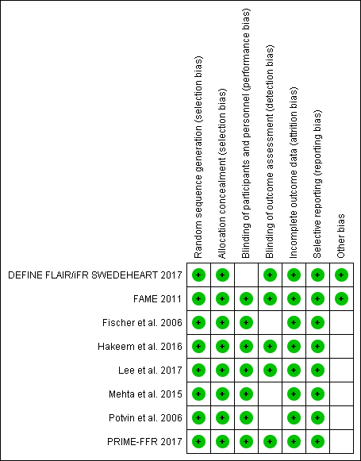

## Figure S1B. Funnel Plot for Assessment of Publication Bias

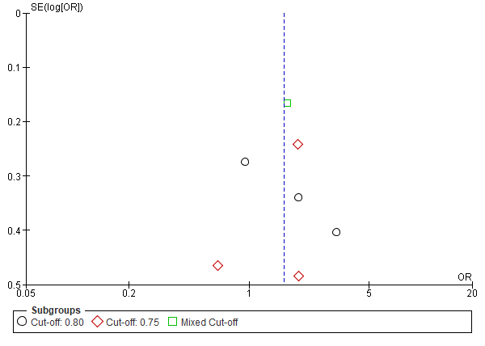

## Figure S2. FFR vs. Angiography alone in the management of patients with ACS. A) MACE; B) All-cause mortality; C) Recurrent myocardial infarction; D) Unplanned revascularisation

A

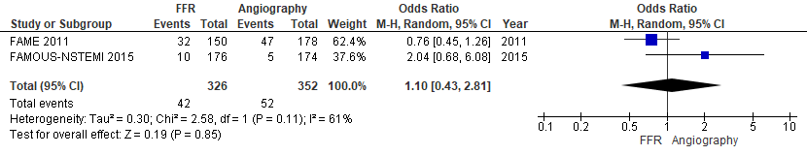

B

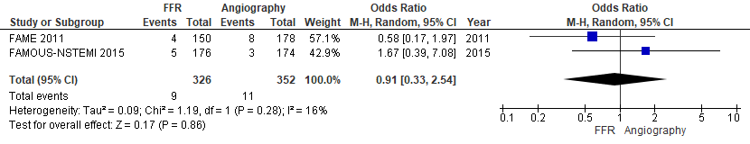

C

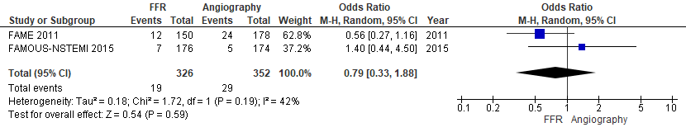

D

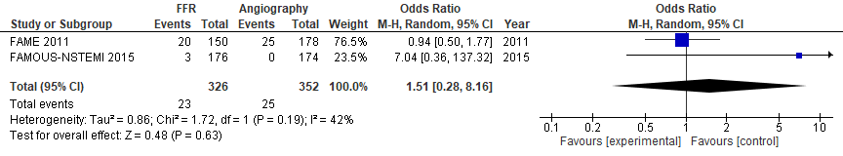

## Figure S3. FFR guided deferral of PCI in patients with ACS and stable CAD: unplanned target vessel/lesion revascularization



## Figure S4. Leave-one-out analysis evaluating the impact of individual study omission from the analysis on the overall effect estimate (incidence of MACE)



# Tables

## Table S1. Selection Criteria and pre-specified endpoints of included studies

|  |  |  |  |  |
| --- | --- | --- | --- | --- |
|  | Inclusion Criteria | Exclusion Criteria | Primary End-point | Secondary End-point |
| FAME | 1. Multi-vessel disease 2. NSTEACS with positive troponin but total creatine kinase < 1,000 U/L | 1. Left main disease, 2. Previous CABG 3. ST-segment elevation myocardial infarction (STEMI) <5 days before 4. Cardiogenic shock 5. Extremely tortuous or calcified vessels 6. Life expectancy < 2 years 7. Contraindication to drug eluting stent 8. Pregnancy | Major adverse cardiac events (death, myocardial infarction, any repeat revascularisation) | 1. Procedure time 2. Amount of contrast agent used 3. Functional class at 1 year  4. Health-related quality of life  5. The number of antianginal medications used 6. The individual components of the primary end point at 1 year 7. The rates of major adverse cardiac events at 30 days and 6 months 8. Cost-effectiveness |
| Potvin et al | NR | Patients within 24 hours of acute ST-elevation MI (STEMI) | NR | NR |
| PRIME-FFR | NR | NR | MACE (all-cause death, MI, unplanned revascularisation) | NR |
| Mehta et al | NR | NR | MACE (cardiovascular mortality, nonfatal myocardial infarction, deferred lesion intervention) | 1. Composite of CV death or MI 2. MI or deferred lesion intervention 3. CV death 4. MI 5. Deferred lesion failure 6. Deferred lesion intervention |
| Hakeem et al | 1. ACS patients who were relatively stable, without signs of hemodynamic or electric instability 2. TIMI III flow | NR | Composite of MI and target vessel failure | 1. Cardiac death |
| DEFINE FLAIR | 1. Age > 18 years of age 2. Willing to participate and able to understand, read and sign the informed consent document before the planned procedure 3. Eligible for coronary angiography and/or percutaneous coronary intervention 4. Coronary artery disease in one or more native major epicardial vessels or their branches by coronary angiogram with visually assessed de novo coronary stenosis in which the physiological severity of the lesion is in question (typically 40-70% diameter stenosis). 5. Stable angina or ACS (non-culprit vessels only and outside of primary intervention during acute STEMI). | 1. Previous CABG with patent grafts to the interrogated vessel 2. Significant left main stenosis (>50% narrowing). 3. Tandem stenoses separated by more than 10mm that require separate pressure guide wire interrogation or PCI (not to be interrogated or treated as a single stenosis) 4. Total coronary occlusions 5. Restenotic lesions 6. Haemodynamic instability 7. Contraindication to adenosine 8. Contraindication to PCI or drug eluting stents  9. Heavily calcified or tortuous vessels 10. Significant hepatic or lung disease, and/or malignant disease with unfavourable prognosis that may influence survival within the next 5 years. 11. Pregnancy 12. STEMI within 48 hours 13. Severe valvular heart disease 14. ACS patients in whom more than one target vessel is present | 1. Major adverse cardiovascular event at 1 year (Death, nonfatal MI, unplanned revascularisation) | NR |
| SWEDEHEART | 1. Informed consent  2. Patient must be ≥ 18 years old 3. Patients with suspected stable angina pectoris or unstable angina pectoris/NSTEMI who are scheduled to undergo coronary angiography, and where there is an indication for physiology guided assessment of coronary lesions (recommend assessment of lesions with a stenosis grade of 40-80%). | 1. Previous CABG with patent grafts to the interrogated vessel. 2. Inability to provide informed consent. 3. Previous randomization in the iFR-SWEDEHEART trial. 4. Known terminal disease with a life expectancy of less than one year. 5. In patients with multi-vessel disease and other indication than stable angina pectoris, difficulty in assessing which is the culprit lesion. 6. Patient with unstable hemodynamics (Killip class III-IV). 7. Inability to tolerate adenosine 8. Heavily calcified or tortuous vessels where inability to cross the lesion with a pressure wire is expected. | MACE (all cause mortality, nonfatal myocardial infarction, unplanned revascularisation) | 1. Components of primary endpoint 2. Chest discomfort during procedure 3. Target lesion revascularisation 4. Stent thrombosis 5. Restenosis |
| Fischer et al. | NR | NR | NR | NR |
| Lee et al. | NR | 1. Depressed left ventricular systolic function (ejection fraction <35%) 2. Acute ST-elevation myocardial infarction (STEMI) within 72 hours 3. Previous coronary artery bypass graft surgery (CABG) 4. Abnormal epicardial coronary flow (TIMI flow <3)  5. Planned CABG after diagnostic angiography | MACE (cardiac death, target vessel related MI, target-vessel related ischemia driven revascularisation) | NR |

## Table S2. Baseline Lesion Characteristics

|  |  |  |  |  |  |  |  |
| --- | --- | --- | --- | --- | --- | --- | --- |
| Studies | Groups | LMCA, n (%) | LAD, n (%) | LCx, n (%) | RCA, n (%) | Grafts, n (%) | Multi-vessel Disease, n (%) |
| FAME | ACS | NR | NR | NR | NR | NR | NR |
| Stable | NR | NR | NR | NR | NR | NR |
| PRIME | ACS | 31 (4.5) | 389 (56.9) | 135 (19.7) | 125 (18.3) | 2 (0.3) | 230 (46.0) |
| Stable | 111 (5.9) | 1,069 (57.1) | 284 (15.2) | 391 (20.9) | 14 (0.7) | 552 (40.8) |
| Potvin et al^ |  | 29 (13) | 107 (46) | 45 (19) | 50 (22) | NR | 35 (18) |
| Mehta et al | ACS | 29 (7) | 182 (44) | 90 (22)* | 96 (23) | 14 (3) | 221 (66) |
| Stable | 27 (7) | 162 (40) | 118 (29)* | 88 (22) | 10 (2) | 209 (61) |
| Hakeem et al^^ | ACS | NR | NR | NR | NR | NR | 134 (67.0) |
| Stable | NR | NR | NR | NR | NR | 130 (65) |
| DEFINE FLAIR^ |  | NR | 845 (52.5) | 333 (20.7) | 393 (24.4) | NR | 519 (41.5) |
| SWEDE HEART^ |  | 16 (1.6) | 469 (47.9) | 179 (18.3) | 196 (20.0) | NR | 368 (36.1) |
| Fischer et al. | ACS | NR | 19 | 10 | 10 | NR | 9 (26) |
| Stable | NR | 33 | 22 | 19 | NR | 9 (12) |
| Lee et al. | ACS | NR | 121 (26.9) | 162 (36.1) | 166 (37.0) | NR | NR |
| Stable | NR | 785 (31.6) | 860 (34.6) | 839 (33.8) | NR | NR |

^Whole FFR cohort

^^ Propensity Matching

* p<0.05