Supplementary A1
 | Responders |  |  | Non-Responders |  |  | Response P-value | Time P-value | Interaction P-Value
Parameter | Baseline | 6 weeks | 6 months | Baseline | 6 weeks | 6 months
6MWT (M,mean±SD) | 237.6±130.5 | 304.8±129.0 | 325.1±147.5 | 239.4±127.4 | 265.5±127.7 | 194.9±159.1 | 0.16 | <0.01 | <0.01
QoL Score (mean, range) | 50 (9-86) | 19 (0-64) | 21 (0-72) | 48.5 (8-101) | 28.5(0-73) | 32 (0-83) | 0.3 | <0.01 | 0.01
LVESV (ml, median, range) | 119.3 (49.4-268.7) | 96.0 (41.4-210.8) | 74.9 (30.1-315.6) | 110.2 (56.0-169.4) | 111.2 (56.8-191.6) | 74.2 (24.9-179.7) | 0.20 | 0.01 | 0.55
LVEF (%, mean±SD) | 24.1±7.8 | 29.5±8.9 | 33.4±10.8 | 24.5±8.7 | 30.4±9.6 | 33.1±7.1 | 0.66 | <0.01 | 0.93
NT-pro-BNP (pmol/L, median, range) | 207.0 (53.0-4138.0) | 173.0 (27.0-3848.0) | 116.0 (15.0-1690.0) | 255.5 (67.0-547.0) | 265.5 (49.9-896.0) | 184.0 (30.9-1437.0) | 0.59 | 0.96 | 0.27
Hs-TnT (ng/L, median, range ) | 26.4 (8.5-233.0) | 24.0 (6.7-61.9) | 23.1 (6.5-63.2) | 27.6 (6.5-61.8) | 29.2 (8.4-77.3) | 31.2 (14.5-83.1) | 0.84 | 0.82 | 0.35
PINP (ug/L, median, range) | 43.0 (22.0-141.0) | 48.0 (29.0-136.0) | 53.0 (13.0-107.0) | 38.0 (15.0-113.01.60±0.20 | 39.0 (16.0-69.0) | 41.0 (14.0-94.0) | 0.04 | 0.02 | 0.41
CTx (ug/L,, median, range) | 0.48 (0.14-1.14) | 0.43 (0.08-1.06) | 0.38 (0.07-1.30) | 0.31 (0.16-0.73) | 0.27 (0.16-0.59) | 0.30 (0.10-0.79) | 0.05 | 0.33 | 0.36
PIIINP (ug/L,mean±SD) | 1.09±0.35 | 1.10±0.32 | 1.01±0.36 | 0.94±0.43 | 0.65±0.50 | 0.87±0.47 | 0.13 | 0.1 | 0.44
MMP-2(ug/L, median, range) | 258.8 (157.0-789.5) | 241.3 (163.9-695.2) | 243.2 (159.8 (159.8-625.4) | 323.5 (155.3-543.4) | 295.1 (162.0(512.3) | 299.8 (162.4-515.9) | 0.51 | <0.01 | 0.19
MMP-9 (ug/L, median, range) | 71.8 (13.6-254.1) | 52.3 (5.6-192.9) | 61.3 (8.8-126.1) | 80.8 (13.6-254.1 | 65.2 (29.5-129.6) | 58.3 (16.9-143.3) | 0.77 | 0.01 | 0.66
GDF-15 (ug/L, median, range) | 2.66 (1.12-10.29) | 2.69 (0.97-6.27) | 2.34 (0.99-5.68) | 2.75 (1.20-5.95) | 3.06 (1.09-5.54) | 3.63 (1.32-8.49) | 0.20 | 0.41 | 0.08
miR-21 (RQ, median, range) | 0.77 (0.3-1.9) | 0.65 (0.31-1.98) | 0.71 (0.32-1.85) | 0.82 (0.5-2.4) | 0.83 (0.53-2.31) | 0.66 (0.34-1.41) | 0.39 | 0.15 | 0.75
miR-30d (RQ, median, range) | 0.81 (0.2-2.55) | 0.72 (0.35-1.85) | 0.76 (0.37-1.28) | 0.68 (0.29-2.27) | 0.99 (0.4-1.84) | 0.61 (1.78-1.65) | 0.56 | 0.9 | 0.14
miR-122 (RQ, median, range) | 0.45 (0.08-3.60) | 0.33 (0.10-2.61) | 0.43 (0.10-2.07) | 0.69 (0.06-2.48) | 0.84 (0.10-2.18) | 0.44 (0.20-5.74) | 0.03 | 0.12 | 0.53
miR-133a (RQ, median, range) | 0.34 (0.01-4.52) | 0.46 (0.01-15.45) | 0.64 (0.01-3.75) | 1.28 (0.01-3.79) | 0.29 (0.01-2.42) | 0.30 (0.01-2.75) | 0.5 | 0.49 | 0.16
miR-210 (RQ, median, range) | 0.57 (0.17-5.12) | 0.85 (0.05-4.05) | 0.61 (0.13-3.08) | 0.79 (0.03-3.61) | 0.63 (0.02-3.59) | 0.78 (0.04-4.01) | 0.85 | 0.85 | 0.81
miR-486 (RQ, median, range) | 0.87 (0.17-3.14) | 0.69 (0.32-3.15) | 0.56 (0.33-1.59) | 0.73 (0.21-2.48) | 0.93 (0.36-1.89) | 0.60 (0.17-1.01) | 0.51 | 0.05 | 0.63
Behavior of Functional LV Geometry and Vascular Biomarkers Following CRT Implantation. Interaction between responders status and over time analysed.

Supplementary A2
Trends in functional variables, LV geometry and biomarker expression following CRT in responders and non-responders
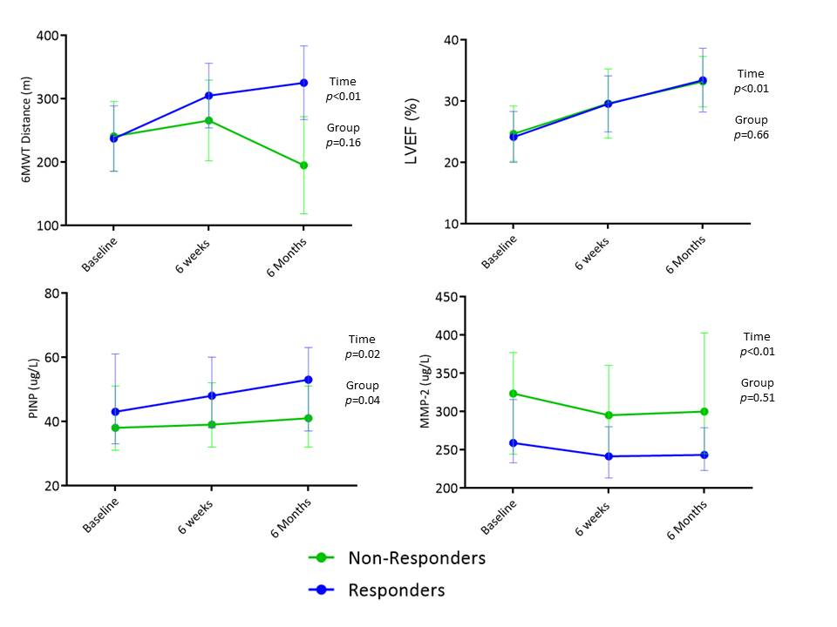

Supplementary A3
Bivariate correlation analysis of short/long-term changes following CRT between biomarkers versus functional and echocardiographic variables
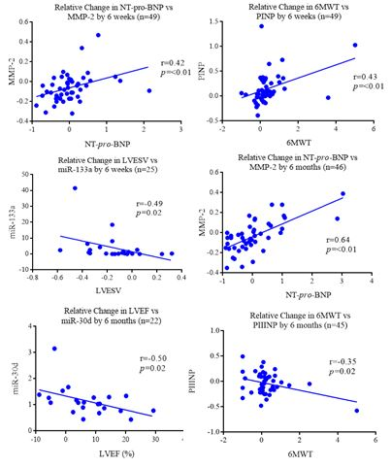

Supplementary A4
Univariate and Multivariate Regression Model of Pre-CRT implant variables for prediction of functional response at 6months
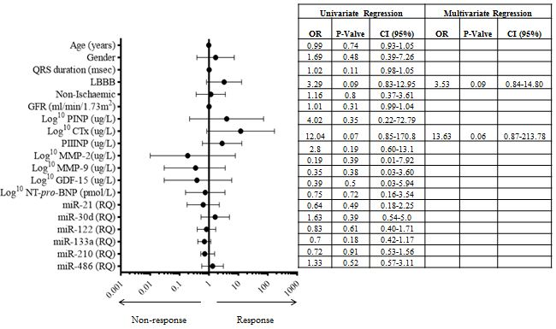

Supplementary A5
Variation between biomarker expression in peripheral and coronary sinus blood
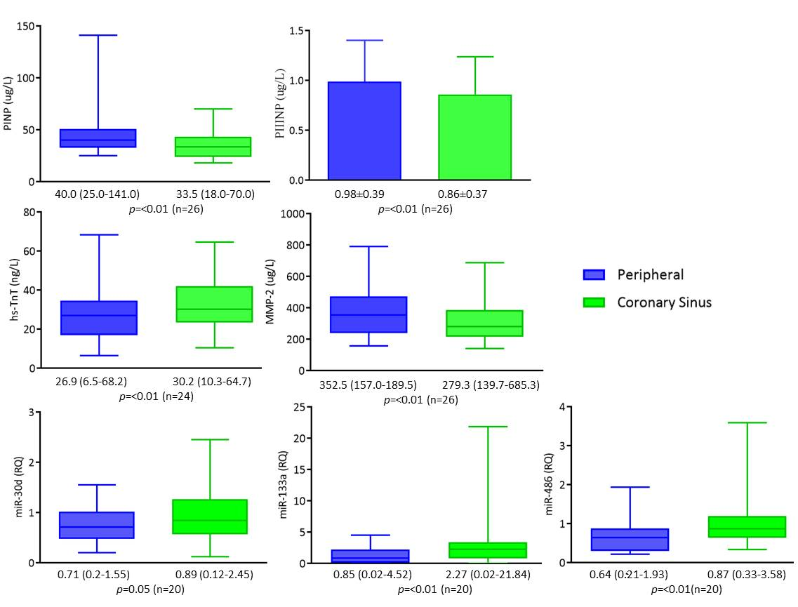

Supplementary A6
Comparison between baseline biomarker expression for participants with and without MACE at 12 months following CRT implantation.
Biomarkers | MACE = 8 | No MACE = 44 | p-value
Log¹⁰ PINP (ug/L, mean±SD) | 1.69±0.15 | 1.64±0.18 | 0.45
Log¹⁰ CTx (ug/L,mean±SD) | -0.37±0.11 | -0.42±0.24 | 0.31
PIIINP (ug/L,mean±SD) | 1.25±0.49 | 1.01±0.37 | 0.15
Log10 MMP-2(ug/L,mean±SD) | 2.46±0.14 | 2.49±0.16 | 0.94
Log10 MMP-9 (ug/L,mean±SD) | 1.96±0.20 | 1.84±0.26 | 0.35
Log10 GDF-15 (ug/L,mean±SD) | 0.42±0.20 | 0.41±0.23 | 0.81
miR-21 (RQ, median, range) | 0.79 (0.50-1.0) | 0.75 (0.30-2.40) | 0.86
miR-30d (RQ, median, range) | 0.53 (0.35-0.87) | 0.71 (0.20-2.55) | 0.05
miR-122 (RQ, median, range) | 0.60 (0.14-1.38) | 0.50 (0.06-3.60) | 0.54
miR-133a (RQ, median, range) | 1.23 (0.02-3.35) | 0.53 (0.01-4.52) | 0.47
miR-210 (RQ, median, range) | 0.79 (0.06-1.43) | 0.68 (0.17-5.12) | 0.61
miR-486 (RQ, median, range) | 0.77 (0.28-1.90) | 0.76 (0.17-3.14) | 0.57

